**Web-based job application and tracking system used to help job seekers apply for jobs in various companies**

**Jane Martha**

**121931**

**Technology at Strathmore University**

**Submitted in partial fulfillment of the requirements of the Diploma of Business in Information**

**Technology at Strathmore University**

**Strathmore Institute of Management and Technology**

**Strathmore University**

**Nairobi, Kenya**

**February 2020**

Declaration and Approval

I declare that this work has not been previously submitted and approved for the award of a diploma by this or any other University. To the best of my knowledge and belief, the research Job application System contains no material previously published or written by another person except where due reference is made in the research job system itself.

Student: Jane Martha

Sign: ________________________ Date: ________________________

Supervisor: Dickson Owuor

Sign: ________________________ Date: ________________________

Abstract

In life we all get to this stage of seeking for jobs, previous it was hard but with advancement in technology, it has made it easy for people to seek for various jobs based on their qualifications and skills. There for online job application and tracking systems that is concerned with hiring, processing, managing and organizing applicants and their details. This system should be given priority since one does not need to move from one place to another, carrying all their documents as this may be tiring and there’s a high risk of losing the documents, being stolen and also its expensive when it concerns paying fare. Furthermore, it will be a waste of time since getting a job depends on one’s luck or interest of the company. The solution is there for a web-based application system apply for a certain job based on their skills and qualifications. The system allows job seekers to log in into the system and view the available jobs based and then they select a given position that have been displayed by the company based on their interest and interest of the company and then after application the applicant give a brief description of why they are interested in that position and they send their cv .The selected company receives the applicant’s details and if he or she meets the company qualification and interest the company sends feedback to inform them that they have qualified or that they were not able to meet the companies qualifications. The system should enable the companies view those who have applied for any given position. This system was been developed using methodology .and all phase of the systems were completed.

Table of Contents

Declaration and Approval ii

Abstract iii

Table of Contents iv

List of Figures viii

List of Abbreviations ix

Chapter 1: Introduction 1

1.1 Background of Study 1

1.2 Problem Statement 2

1.3 General Objective 2

Specific Objectives 3

1.4 Justification 3

1.5 Scope and Limitations 3

Chapter 2: Literature Review 4

2.1 Introduction 4

2.2 Jobseekers in Kenya 4

Challenges Faced by Jobseekers in Kenya 4

2.3 Related Works 5

2.3.1 Weapss 5

2.3.2 Era 6

2.3.3 United nation Career 7

2.3.4 UNOPS 8

2.4 Gaps of Existing Systems 9

2.5 Conceptual Framework 9

Chapter 3: Methodology 11

3.1 Introduction 11

3.2 System development approach 11

3.2.1 Requirements Analysis 12

3.2.2 Design 12

3.2.3 Implementation 13

3.2.4 Testing 13

3.2.5 Deployment 13

3.2.6 Maintenance 13

3.3 Justification of Modified Waterfall Methodology 13

3.4 Tools and Techniques to applied 13

3.4.1 HTML 13

3.4.2 PHP 13

3.4.3 MySQL 13

3.4.4 CSS 14

3.4.5 Bootstrap 14

3.4.6 Database Schema 14

3.4.7 ERD 14

3.5 System Deliverables and Milestones 14

3.5.1 Jobseekers 14

3.5.2 Company Manager 14

3.5.3 Administrator 15

Chapter 4: Systems Analysis and Design 16

4.1 Introduction 16

4.2 Analysis 16

4.3 System Requirements 16

4.3.1 Functional Requirements 16

4.3.2 Non-Functional Requirements 17

4.4 System Design 17

4.4.1 Use Case Diagrams 17

4.4.2 System Sequence Diagram 18

4.4.3 Dataflow Diagram 19

4.4.4 Activity Diagram 21

4.4.5 Database Schema 22

Chapter 5: System Implementation 24

5.1 Introduction 24

5.2 Description of Implementation Environment 24

5.2.1 Hardware Specifications 24

5.2.2 Software Specification. 25

5.3 Description of Testing 25

5.3.1 Testing Paradigm 25

5.4 Subset of Functional and Non-Functional Requirements Tested 26

5.4.1 Authentication 26

5.4.2 Availability 26

5.4.3 Security 26

5.4.4 Testing Results 26

Chapter 6: Conclusions, Recommendations and Future Works 28

6.1 Conclusions 28

6.2 Recommendations 28

6.3 Future Works 28

Reference 29

Appendix-Gantt Chart 30

List of Figures

Figure 2.1 Era 6

Figure 2.2 United nation Career 7

Figure 2.3 UNOPS 8

Figure 2.4 Conceptual Framework 10

Figure 3.1Modified Waterfall Methodology 12

Figure 4.1 Use Case Diagram 18

Figure 4.2 System Sequence Diagram 19

Figure 4.3 Context Level DFD 20

Figure 4.4 Level 0 DFD Diagram 21

Figure 4.5 Activity Diagram 22

Figure 4.6 Database Schema 23

Figure 5.1 Gantt Chart 30

List of Abbreviations

SSAD- Structured System Analysis and Design

CSS-Cascading Style Sheet

HTML-Hyper Text Markup Language

PHP-Hypertext Preprocessor

ERD-Entity Relation Diagram

# Introduction

## Background of Study

A job is a task or a piece of work which is done in exchange for payment. There are various types of jobs but they vary with skills and qualification and the interest of the company. There are various reasons as to why people seek for jobs, which include better payment. This happen when an employer in his or her current jobs is not being paid well or she is not satisfied with the amount of salary. Therefore, one has to seek for better opportunities in order to satisfy his or her demand; also some people seek for new employment due to discrimination in terms of race, tribe, level of education, culture, these causes people to try find for better places where they don’t have to face such problems. furthermore people seek for jobs in order to change location so as to be closer to their families depending on emerging issues such as sickness, in order to look after their families or due to security purposes (Maartenv, 2015).

Secondly, people seek for employment so that they can eradicate poverty. This is the main reason that make people migrate from rural areas; leaving their families behind in order to come to the cities to seek for jobs. The main reason is to earn income so that they can meet their personal needs, live in a better condition and also be able to take care of their families’ needs back at home in terms of food, medical care, transport and other various need that occur in a family. Other people want to complete or further their educations and that is why they would end up working so that they can be able to pay for their fees. Lastly some people would seek for employment in order to earn income so that they can enjoy their hobbies such as travelling and doing other things for fun (Caroline, 2020).

Thirdly, doing the same job for so many years it becomes boring and their fore, people want to try new challenging task and that is why they would end up seeking for new jobs. Also working in the place where a person is overworked yet their salary is not being increased, it makes the person seek for better places where his or her right is respected. Some companies don’t have higher goals and maybe they don’t consider the interest of their employees or can’t allow their workers to also share their opinion or even make corrections and suggestion in case the company is not performing well, the might make some workers fill intimidated, disrespected and thus changing jobs (Kelly, 2020).

Lastly, some people seek employment in order to work for big companies so as to promote their identity to the public and earn respect from the outsiders and get better payment from the payment. Also people will seek employment in order to acquire more skills so that they can also establish their own companies and practice the skills acquired from previous businesses and be able to become their own boss, create employment for their relatives or avoid being given instructions, since some people hate being commanded in front of their colleagues.

## Problem Statement

We can’t specify the number of people who uses internet to access for jobs opportunities. The availability of these systems makes it easier for various jobseekers to access information for various jobs and analyze if they qualify or they don’t qualify. It’s the existence of these jobs that one is able to cater for their personal, family’s needs and also societal needs such as food, medical care, education and other unplanned needs which come later after the main needs have been satisfied. Therefore, this indicate the developers of these system should be careful and ensure that the system required or developed is able to allow people apply for jobs of their own interest and give a feedback after all the process is completed. Also, should ensure that the applicant’s details are protected and cannot be accessed by any unauthorized persons. In today’s generation it is hard to find a job without connections, bribe, corruptions which are the leading activities. However not everyone or company is like that and that means that one should try out their chances by offering better skills and qualifications and show commitment that they really want that job. Not forgetting that there are so many graduates outside there with better skills and qualifications yet jobless and still more students are graduating to join the existing group that are jobless, the lucky one will maybe find jobs in their relative’s companies or get help from their parents to start their own personal business but what about the less fortunate.

The solution for these problems to create a system that gives equal opportunity for everyone to get a job irrespective their tribe, race, or religion.

## General Objective

Came up with a web-based system that was to allow jobseekers apply for a certain job in a given company, provide a short description of why they want that position and then submit the cv to the selected company and finally wait for feedback.

### Specific Objectives

1. Analyze and study how various jobseekers have been able to acquire and access their current jobs.
2. Study and analyze existing job application and how their challenges have been solved.
3. To design and develop a system that will address the specified challenges.
4. Analyze challenges faced by jobseekers while applying for various jobs.

## Justification

The proposed system was to allow jobseekers to view various jobs offered by different companies, apply for their job of interest based on their qualifications, and skills, Then provide a short description or reasons as to why they need that position and finally upload and submit their cv to the selected company. The selected company views the applicants details and then decide if the applicant meets their qualification and interest and if they do, the company sends feedback to the applicant and an approval that they qualify to work with them and in case the company feels that the applicant does not qualify or he or she does not meet their interest or qualification also a feedback back is send to inform them as a way of allowing them to try another place and the company disapprove them.

## Scope and Limitations

The proposed system was to allow the jobseekers to check the available jobs offered by the various companies, apply, and provide a brief description of why they need that job then send their details to the selected companies and the selected company was to view the applicants detail when they login into the system and determine whether the candidate is suitable, qualifies to work for their company. Then feedback is sent by the selected company in case the applicant qualifies the company then sends an approval letter. The company the post the new positions stating what the interested candidate should possess.

The proposed system was to allow the applicants to apply one position as offered by the company. The system works on all electronic devices such as phones, computers, laptops and other devices that can help a jobseeker apply for any job in any given company. The applicant cannot get has already been taken the system will inform the all the other companies who try to select the same candidates and it will not allow the any candidate to apply more than twice.

Only the qualified candidates will be able to interact with the companies that selected them.

# Literature Review



## Introduction

This chapter talks about various available jobs in Kenya and how different jobseekers to try to acquire them. providing a brief information about these jobs, challenges face by jobseekers and systems that are available.

## Jobseekers in Kenya

A job is a task done in for the purpose of satisfying ones needs, demands and want, basically primary needs and secondary needs. There are various jobs within the country based on one interest, qualification, and lastly skills. Payment for any job done varies (Ahmed, 2018). Furthermore, one need to know demand of different companies and see if one is fit to partner with any of the company. One can apply for any job manually or use of machines such as computers and laptops or other means that are available. However, it is preferable to cop up with advancing technology since it’s easier and time saving. There are various ways that direct one on how to apply for any job online (Alison, 2019).Lastly there also chances of self-employment, where a person is allowed to build their own business depending on the amount of income one has.

Any person who is seeking for any job should be aware of the demand needed by various companies. The person should ensure that their qualifications and skills required based by the type of business are efficient and effective. Also one should ensure that the identify company is serious about it recruitments since some companies don’t real mean it and it end up being a waste of time.

### Challenges Faced by Jobseekers in Kenya

It is hard to decide where to start from due to many suggestions. There are so many jobs available and it may end up being hard and confusing to choose the best one especially if one qualifies for more than one job. Also presence of many people giving different opinion about their own point of view may make it hard for one to sit down and come up with the best alternative. It might also be hard especially when one is a graduate and they have no idea of where to begin, this because one is not experienced at being self driven and fear of facing challenges and failures (Ahmed, 2018) (Alison, 2019).

Companies offering certain limitations, certain percentage, Period of experience. Some companies or businesses have limitations on number of candidates required. This makes it inconvenient for most of jobseekers especially if one finds out that the stated number of applicants has already been achieved while he or she has better qualifications and skills. It also makes it hard for companies which specify the numbers of years one should have worked for any other company, since one is termed out more experienced based on numbers of years. It is not fair a graduates since they are not experienced a lot and need more time to be trained, monitored, and supervised. This leads to unemployment hence poverty. it also takes time for the company to select the candidates fairly since there are so many applicants.

Few companies with job vacancy. There are only few companies with open jobs with a large number of candidates, thus making it difficult to give each one an opportunity. Since one takes. time to realize what actually they want, they end up finding that their chances have already been given to the other candidates. This is because companies have their own goals and strategies to fulfill which is to make profit and anytime wasted brings a greater loss for a serious company.

## Related Works

These are systems that have been implemented to the public to help come up with solutions for job applications. Various jobseekers can log into the system and apply for various jobs from different companies. There are various type of these systems which include, The WEAPSS, Era, United nation CAREERS, UNOPS.

### Weapss

The Weapss is an application system for both the applicant and the departments offering various job vacancies. The system was built in May 2008, The system provides new job online jobs together with application forms, including new position and also process for application for the employees and personal action process. The purpose for this system is to solve problems faced by any online job applicant and departments involve (shakya, 2008)

### Era

The Era is a system that displays the available positions and links to help the applicants apply for a certain displayed position by the system, the system also assists the applicant with steps to follow in order to be able to answer the provided questions as required and submit the required documents to a certain department following a certain link. It will also enable the user to create a personal account in order to store their documents and access the in future in case one want to apply for a different position. The main purpose for this system is to help applicants apply for jobs as it offers to guide them with various steps on how to apply (jobs at the Embassy/U.S. Embassy in Kenya, 2020)

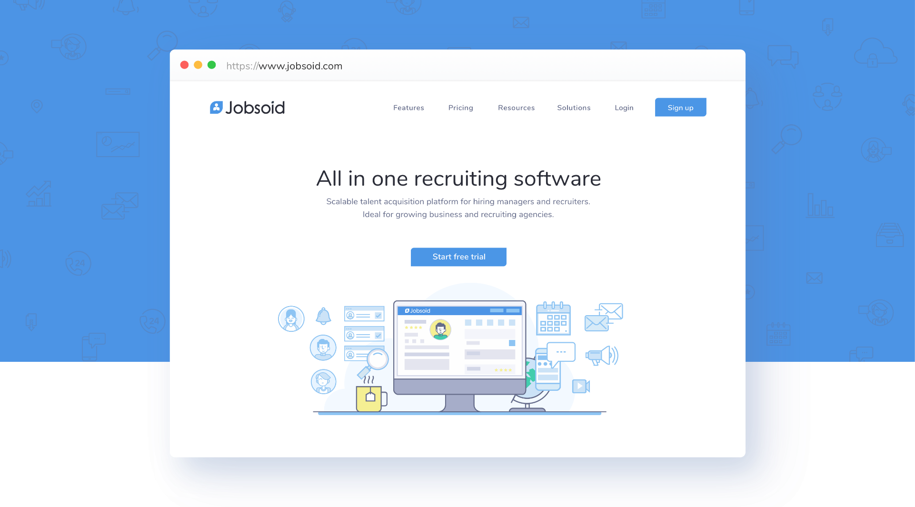

Figure . Era

### United nation Career

United nation Career is a system that provide application process for various jobs. The system mainly gives the first priority to women who seek for jobs through it. It does not charge any fee at all the stages of recruitment (interview meeting, application, processing and training) Furthermore it is not concerned with bank information of its candidates. The system displays various jobs, duration of application together with deadline. The main purpose for this system is to enable jobseekers apply for a certain job and get feedback (UN Careers, 2020)

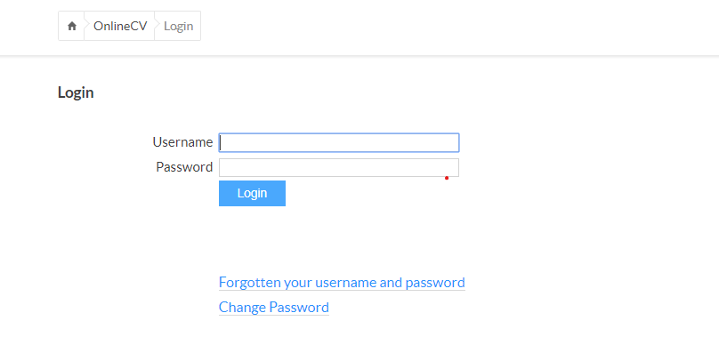

Figure . United nation Career

### UNOPS

The UNOPS is an online recruitment system that advertises jobs opportunities and ensures that the candidate is transparent and efficient. The system enables the applicants create a profile, apply for a current available vacancy, register, monitor their status of application and search for available opportunities. It provides guideline on how to carry on with application up to the final stage of submission of the required documents. The UNOPS system solves the normal issues all jobseeker under (UNOPS Jobs)

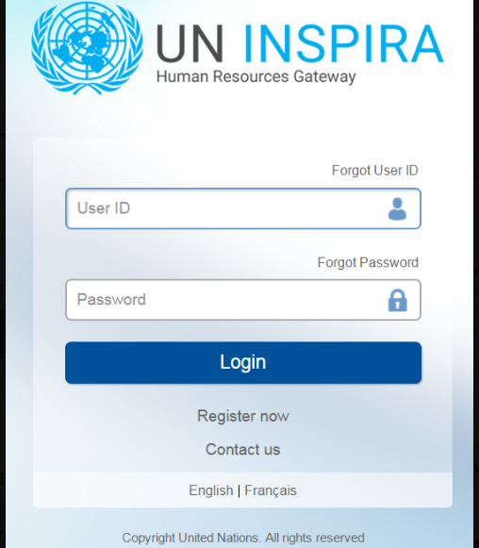

Figure . UNOPS

## Gaps of Existing Systems

There are many available systems that are used to help people apply for particular jobs but unfortunately these systems lack some services which are addressed by job application system. There was a need for a system that would enable applicants apply for and get reply after a certain duration of time. There was a need for a system that would display the available jobs and information about a certain company. There was need for a system that would allow job seekers include all their qualifications together with a CV as required by the organizations. There was a need for a system that will enable the candidate determine if they qualify and the duration given to them so that they join training or whether to start working directly. The application system allows the applicants to register for a given job and also select company of interest. then submit their details to the selected company, the system ensures that the jobseeker can only select positions which matches their interest, it also ensures that other companies can view those who have applied for various positions.

## Conceptual Framework

Figure 2.5 is a simple diagram that illustrates the functions of job application system. It shows how the system the system carries its activities. The entities that are involved in this system are: the job applicants, manager, and the system administrator. The customer and the manager and the manager register before login into the system as users. The applicants then read instructions and information provided by the system, then they view the current positions together with companies advertising those positions as per the way they are displayed the system, the applicants have a chance of selecting a maximum four positions and four companies of interest but offering the positions they are applying for. They then provide their details as required by the companies and then submit their details at once, The manager then logins into their system and they are able to see the details of the applicants, They read and analyze if the applicants qualifies for any the position selected, if yes , then send a message to the applicant informing them that they met the standards required by the company and then they are booked date of appointment which interview will be conducted and finally the system displays fee charges for the registration. Once a particular candidate is selected a notification will be displayed to all the other companies to inform them that he or she has been selected by that company and so they are not able to select them twice. The applicants then are free to interact with the company that appointed them via the system. The administrator contributes on ensuring that the system well taken care of and properly maintained.

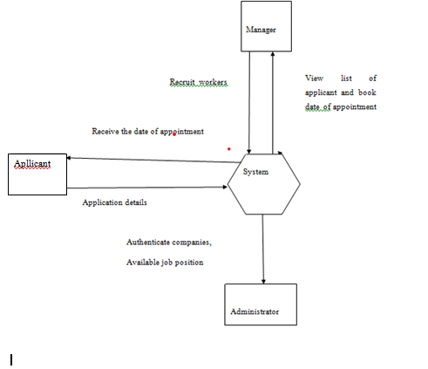

Figure . Conceptual Framework

# Methodology

## Introduction

The chapter talks about the methodology being used on developing the application system, software engineering provides variety of process models to be used when developing a system such as agile model consisting of incremental model, iterative model. The models are different and they don’t serve the same purpose as it depends with the type, size, skill needed for the development, availability of resources to design the project and specifications, duration it will take to complete the of project and submit it to the main customer.

## System development approach

The job application system has been developed using the waterfall method. This is because the model assumes that all the planning and requirements, tools for the development of the project have been made. The model does not foresee need for future changes and it displays steps to be followed meaning each stage has to be completed before moving to the next stage. This project is developed using the SSAD approach in which it ensures each phase of a system is completed before moving to the next phase, till all the phases have been completed. It also ensures all procedures and objectives have been met. Developers aim at establishing a system that is of high standards and better quality to their clients.

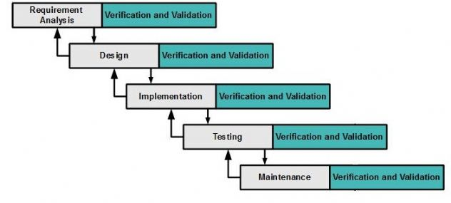

Figure .Modified Waterfall Methodology

### Requirements Analysis

The system requirements of job application and tracking system have been identified. They include user requirement, such as jobseeker being able to apply for various position from different companies and being scheduled for the day of appointment after submitting all the required details and after they have qualified and met the company’s standards. Presence of functional requirements in which the users can register, login to the system. Non-functional requirements such as speed, storage, availability.

### Design

A brief description on how the system will be developed and established in order to solve the jobseeker’s problem by providing an existing system as solution for all the problems they face. all the identified functional features of building the system have been described separately. The specifications, development, testing, deployment and maintenance are successfully accomplished.

### Implementation

The job application and tracking system has been implemented using the, HTML.CSS, PHP, MYSQL.

### Testing

Testing was done to ensure that the system meets all the requirements of the user and fixing of bugs in the code. The users are able to test the system by applying for some job position after filling the required information to check if the system really meets the its main purpose then they are allowed to give their feedback, whether to improve, add or features to the system.

### Deployment

On this stage the system was released to the market after it was assuring that it was functioning well.

### Maintenance

On this stage dubbing and additional of features to enhance effectiveness and efficiency and proper functioning of the system.

## Justification of Modified Waterfall Methodology

The modified water fall methodology provides steps on how the system will be developed. Also preferred on developing reliable systems.

## Tools and Techniques to applied

### HTML

This is a markup language that enable browser to structure various link visited and It’s used in coming up with a web page. It is used to insert videos, audios, images make styles, organize the document in a logical order and ensure proper presentation of work in this job application and tracking system.

### PHP

This is a script language and interpreter that is freely available. It is used in combination with various web template systems, web contents, web management systems and web framework.

### MySQL

Creates database to be connected to the system via PHP.

### CSS

Describe the presentation of document used in markup language, JavaScript.

### Bootstrap

This is an open source CSS framework directed at responsive, mobile first responsive front end web development and it contains CSS and Javascript based designed templates for buttons, navigation etc.

### Database Schema

This is a structure described in a formal text database language. It is used to refer to graphical depiction of database structure.

### ERD

A snapshot of data structure that shows entities in a database and relationships between the tables within database structure.

## System Deliverables and Milestones

My deliverable is to create a convenient system that will provide services to the society especially those people in need of jobs and they have no idea of where to begin. Allow people to access the system and be free to apply for different jobs from different companies. Allow people with all level of education be convinced that though the system they will be able to achieve their dream though its depends with their skills and the company requirements. The milestone is to deliver a system that is of high quality and offer better services to the clients who uses it.

### Jobseekers

They are able to view, read information provided by the system about certain companies. Fill in details, select companies of the personal choice and submit the details.

### Company Manager

This system allows managers from the selected companied to view the applicants details when they login into the system. They are then able to select the candidates or deny them the chances. if they select any applicants they are able to send a confirmation message via the system to the select candidate and plan date of appointment for interview.

### Administrator

The administrator is able to deny access to the system to the candidates who are not sure of what they are doing with the system. They also delete all the applicants who have already been selected and are also involved in the authentication and protection of applicants details together with deletion of unwanted information.

# Systems Analysis and Design

## Introduction

This chapter is about system analysis and design of job application and tracking system. This chapter talks about the functions of the system and it also includes the system diagrams, models that shows how the system works.

## Analysis

In this stage, all system requirements and environmental factors were collected. The analyst analyzed all the requirements and made a recommendation that would help to come up with total overview of the architecture at its functions. The application specifications were developed together with the required inputs and output to meet the applicants and manager’s needs. All these requirement analysis solutions were done through observation.

## System Requirements

These are configurations that are contained in a system so that hardware and software can run more effectively and efficiently.

### Functional Requirements

This part defines the functions of the system’s components to help users accomplish their task. Describes the input of the users and the functions to be added in this system. This is an online system that require user to have devices that require internet and they cannot start using the system’s services before login. The system allows the applicants fill in their details, select companies of that they are interested in working with, they then submit their details to the specified company for the managers of those companies to read them when they login into their devices and select the qualified applicants. Administrator authenticate the available jobs together with companies offering them, and information concerning the companies. Manager is allowed to send a confirmation letter through the system and book appointment. The administrators can deleted irrelevant information posted in the system.

### Non-Functional Requirements

These are requirements that specifies ways used to judge the operation way of a system.

#### Reliability

The system can only be access through internet.

#### Security

The system administrator monitors the activities being carried through the system and deletes unwanted information.

#### Portability

The system can be used by devices that can access the internet.

#### Speed

The system has taken shorter time to provide feedback and process data.

## System Design

In this stage, the process provides data and information concerning the system and the system elements to allow implementations of architectural attributes, entities, relations that are to be included in the system.

### Use Case Diagrams

Involves interaction between the user and the system and it shows relationship between the user and different use cases in user is involved. This is a methodology that is used to identify, organize and clarify the requirements of the system. The job application and tracking system allows the applicant to register before login in the system. The applicant then input their details together with their skills and qualification. They are free to select the company they would want to work for .the system also allows the applicants to access information concerning the company. they are then allowed to submit all their details and qualifications to the selected companies. The manager selects the qualified candidate and sent a confirmation letter together with appointment to the selected candidate. The administrator post currents positions and the companies offering them, he or she post the information concerning the companies together with details concerning the position.

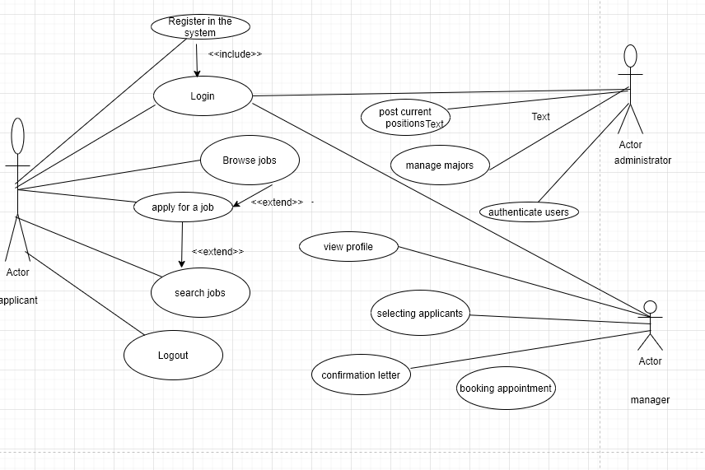

Figure . Use Case Diagram

### System Sequence Diagram

This diagram shows a sequence of activities as objects interacts with each other within the system. The model captures the important information f the system. The applicants log into the system and when they are accepted, they are able to view information concerning the available jobs and the company offering them. The administrator uploads list of current available positions. The applicant selects the position he or she is interested on and insert the required document them submit them to the selected companies. The manager from the selected companies view the applicants and select the qualified one based on the interest of the company. The manager then sends an acceptance letter and books appointment.

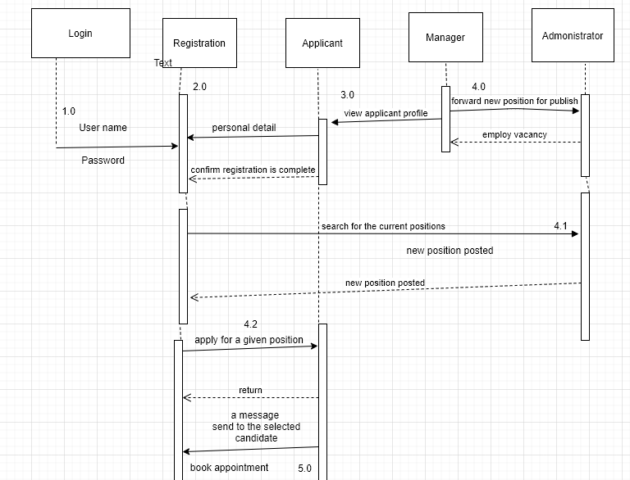

Figure . System Sequence Diagram

### Dataflow Diagram

This diagram represents flow of data process through the system. The context level DFD provides information about the input and output of process and each entities. The system enables the applicants to login and input their details to the details and submit them to the selected companies. The managers from the selected companies select candidates that meets their organization requirements and then they send an acceptance or confirmation letter and then book appointment. The uploads more positions so that many applicants can apply for their position of interest.

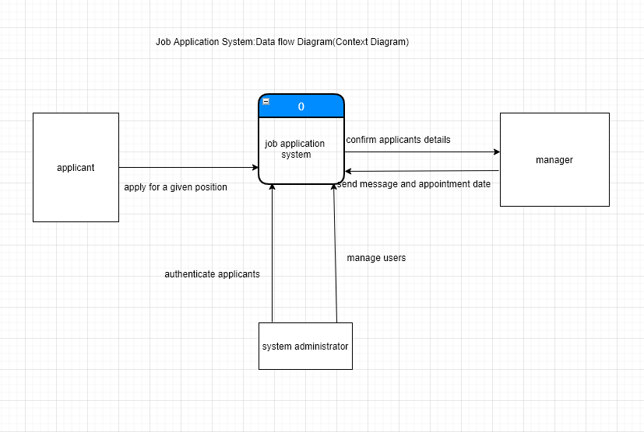

Figure . Context Level DFD

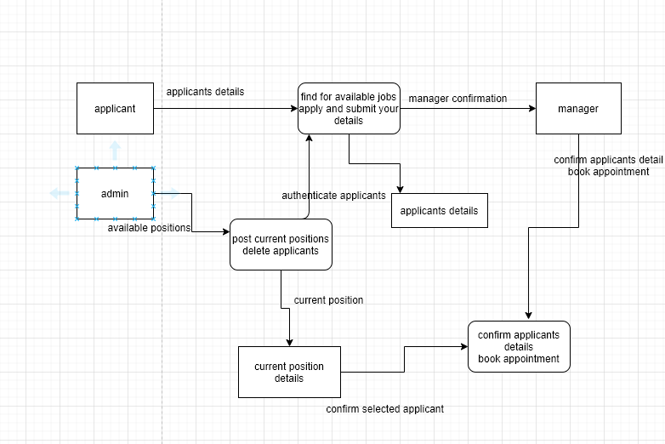

Figure . Level 0 DFD Diagram

### Activity Diagram

This is an UML diagram that shows the execution and flow behavior of a system rather than implementation.

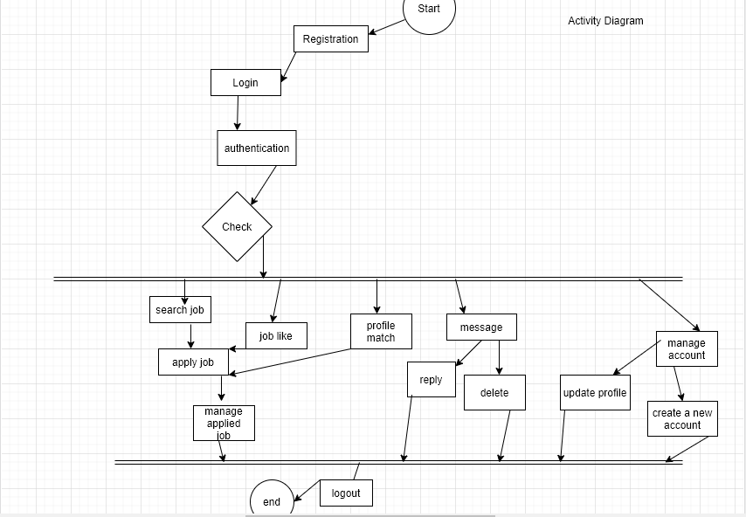

Figure . Activity Diagram

### Database Schema

This is a structure described in a formal language that represents the logical view of the whole database. Defines how data is organized and the association among their relations.

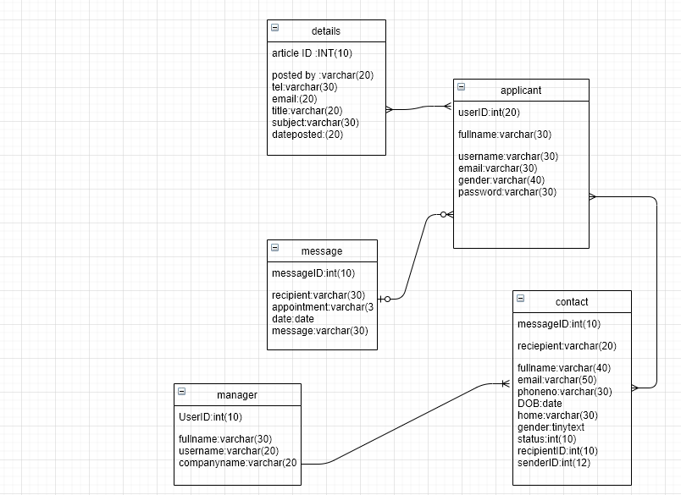

Figure . Database Schema

# System Implementation

## Introduction

This chapter is about how job application system is going to be implemented. It focuses more on how the system is built in terms of physical design, ensuring that the system meets its quality standard and its operating well through testing.

## Description of Implementation Environment

This part provides a short description of software and hardware specifications that were needed

in order to implement the system and to ensure that its operating well.

### Hardware Specifications

The main contemplation for establishing the hardware requirements applicable to the performance of web and database servers. A higher hardware specifications is required.

|  |  |  |
| --- | --- | --- |
| **Item** | **Minimum Specifications (Combined Web and Database Server)** | **Maximum Recommended Specifications (Combined Web and Database Server)** |
| **Processor** | 1 x 1.5Ghz CPU | 1 x 1.5Ghz |
| **RAM** | 2.GB | 7GB |
| **Hard Disk Storage** | 1 x 30GB of free space required for software requirements | |

Table 5.1 Hardware specification.

|  |  |
| --- | --- |
| **Item** | **Specifications** |
| **Processor** | 4 x 3 Ghz Intel Core i5 CPU |
| **RAM** | 8GB |
| **Hard Disk Storage** | 750 GB |

Table 5.2 Developer’s Computer Specifications.

### Software Specification.

The system was developed for a stack surrounding (Linux, Apache, MYAQL, PHP).

#### Operation System

Job application was purposed to run in a standard file system. The system was established within the Ubuntu Linux since it’s an operating system for cloud computing, free and easy to install to windows environment and restrictions imposed by the file system to the environment should not be ignored.

#### Web Server

This Job Application System was devised to work with apache server with no specific configuration required to run this system.

#### Database Server

Job Application System was designed to operate with the community version of Maria DB, MySQL database community. In order to make the system perform its functionality efficiently and effectively: Create, Delete, Read, Update are also considered.

## Description of Testing

Software testing is procedure that assesses the performance a software application with aim of finding whether the software met requirement and to ensure that the product is defect free in order to produce quality product. Therefore, Job Application System was tested to see if the system met it specified requirement and that it was a product of good quality with no defects.

### Testing Paradigm

Black box testing was the main paradigm that was used, Where the only focus was to the input and output. The program execution was inspected to mainly expose failure, the performance and behavioral properties was also tackled. Black testing was mainly chosen to show that the web met its requirement for the users who are not interested on internal code structure, Implementation information and any understating of the internal path of the software.

## Subset of Functional and Non-Functional Requirements Tested

Testing was talked to make sure that aspects of defined functional and non-functional requirement were met.

### Authentication

To check the functionality of the System such as login, both positive and negative values where used such as if an applicant had already log into the system and she logs in again using wrong inputs such as password, email, the system will display ‘ users password don’t match ‘.

### Availability

This is a non-functional requirements, it was tested based on how the web application would response if displayed on various view port sizes corresponding to wider array of devices such as computer, phones, laptops.

### Security

This is also a non-functional requirement and the security was tested on the basis of SQL injections attacks and cross side scripting attacks in order to promote confidentiality and integrity of data.

### Testing Results

The system responded well when the applicant tried to select a given position and applied for it and submitted his application details to the selected company. There were no error displayed and the company was able to view the number of applicants. Also considering the functional and non- functional requirements.

|  |  |  |  |  |  |  |
| --- | --- | --- | --- | --- | --- | --- |
| Test  Scenario | Test  Case | Pre-  Condition | Test  Data | Expected  Result | Actual  Result | Pass/  Fail |
| Check application  functionality | Check  Response  On entering a position  Company name | Launch  Application  Select position  Select company  Click submit button | Position:  Secretary  Company:  Safaricom | Application  Must be successful | Application  success | pass |
|  |  |  |  |  |  |  |

# Conclusions, Recommendations and Future Works

## Conclusions

Most job application data system that were evaluated shows that most applicants don’t get any response from the company in concern although the company offer promising jobs with better payment but do not give feedback to any applicant incase the don’t qualify or if they should re-apply in case the procedure application is not. Job application system has been able to solve this problem for example an applicant applies for a given position in a given company, such as Safaricom the company will offer immediate feedback weather the applicant qualify or does not qualify so that the applicant can decide on the next step in case he or she doesn’t qualify and if she qualifies the company sent an official acceptance letter together with the date of appointment.

This system displays those applicants who have applied for a given position and the company they have applied for any the companies can view those who have applied and view their details then decide whether the applicant meet their qualifications, if yes. The company sent a feedback to the applicant and invite them for an appointment to interview them physically and incase the applicant doesn’t qualify the company also acknowledges the applicant for choosing their company and encourages them to try somewhere else.

## Recommendations

Job application system was tested and deployed on Apache HTTPs Server which is an open source software and can be installed almost in all operating systems thou it cannot handle many visitors at once as compared to IIS. Therefore, job application system should be deployed on IIS for better performance, efficient and effectiveness. The system was actually developed in a PHP 7 environment but for better users experience the system should be installed in PHP7.1.1.

## Future Works

The main users of this system are the applicant, administrator and a manager from any given company. The applicants must have the required qualifications so that he/she can get a chance to any company. Though its hard to measure the skills of the applicant on the system, the given company will give the applicant an appointment in order to conduct interview. The applicant has a chance to apply for any given position and they get immediate feedback from the selected company together with an official acceptance letter incase the qualify.

Reference

Ahmed, M. (2018, October 1). *what is the #1 challenge faced by job-seekers today*. Retrieved from https://www.quora.com

Alison. (2019, March 14). *Age discrimation issues in the workplace*. Retrieved from https://www.thebalancecareers.com

Caroline. (2020, January 25). *Career guide*. Retrieved from https://www.indeed.com/career-advice/interviewing/interview-question-why-are-you-looking-for-a-job

*jobs at the Embassy/U.S. Embassy in Kenya.* (2020). Nairobi: https://ke.usembassy.gov/embassy/jobs/.

Kelly. (2020). Retrieved from Kellyconnect: https://www.kellyservices.us/us/other/kellyconnect-workathome/

Maartenv. (2015, March 3). *10 reasons why you are looking for a new job*. Retrieved from https://toughnickel.com/finding-job/socilicitation

shakya, s. (2008). *Web-based employement application & processing system(Master of Software Engineering).* https:minds.wisconnsin.edu.

Appendix-Gantt Chart

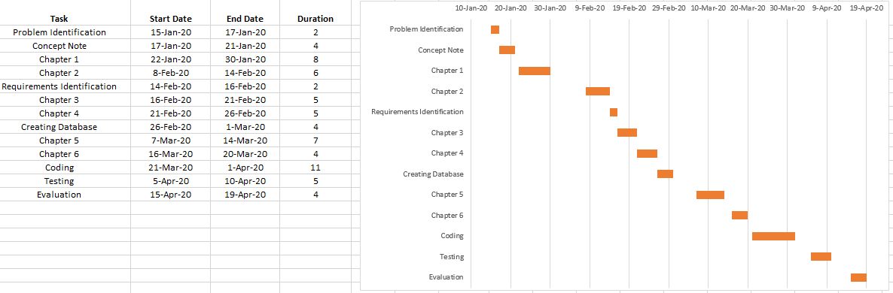

Figure . Gantt Chart